Thursday Renju Class in 5lin.

- 教育訓練組 對 ○助教
Opening i6.

Feb 24 23:17
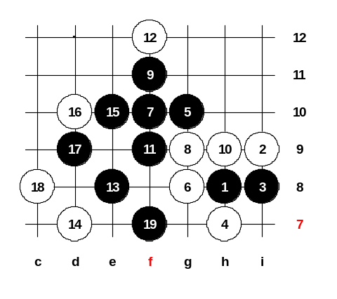
Today we hopefully finish with i6 opening. There is only one more 4th move to study - 4-h7. When the class is over at 11pm, we will have to decide the new opening for next week. After 4-h7, black play is not easy. It needs much knowledge and skill to win here. Does anyone of you know the two best 5th moves here? Yes, g10 is one of them. How about another? The 5-h10 is not good. Yes, 5-g9 is right. I have a question to you. Is g10 same as j6? Does g9 = j7 ?
Basically, the moves are same, but the distance from the board edge influences the win here. Sometimes, when 5-g10 brings easy win, the 5-j6 may have some problems because the board edge is closer. Remember, 5-g8 and 5-j8 are not strong enough. I do not suggest you to play it. OK, lets begin with 5th moves. First we look g10.
The best 6th is g8. Old Japanese style was 7-f9 but I don’t like it because after 8-f10 I am not sure how black must win. Last 10-15 years the people have developed better 7th move - 7-f10. This is sure win. With this 7th move black took very important point, now white is unable to defend. OK, lets look 8-g9. The 9-f11.
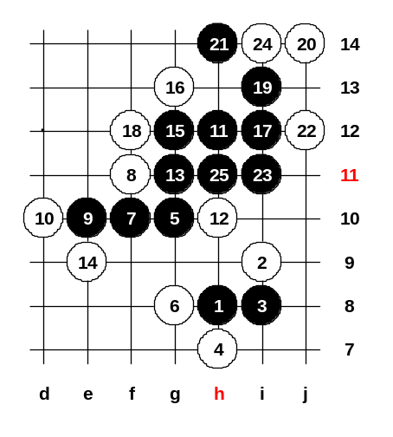

Feb 24 23:14
The 8-f11 is the strongest, I think.
I saw one game where Nakamura showed black win here.
Do you want to look 18-j12 too?

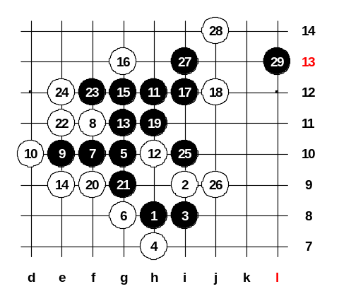
Feb 24 23:12
Beautiful win.
OK, what is the next white stop you want to study?

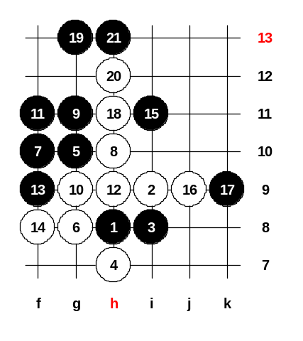

Feb 24 23:11
I am not sure. Maybe 9-f9 is win. Ok, lets try fivestar's move 9-g11. ^^ The 10-g9. Now, what is black next move? Yes, looks like black win. You may try 16-j9 but it doesn’t help much either. The 19-g13 is the win move.

Feb 24 23:06
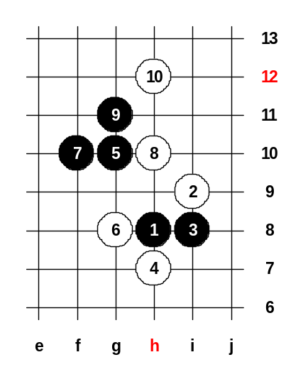
The 10-h12. Lets look for black win here. How about black f11? After 11-f9 white 12-h11. OK, time is late. I suggest we study it at home and find black win here. ^^ This is the homework. I will try to find win too. We can finish our renju class now. Thanks all for join.

fivestar : Feb 25 14:38
11-g9, 12-e11 (12-I7 -> B f11, e11 win)
13-f11, 14-h9 (14-e12 -> B g12, d10 win )
15-f9, 16-f12 (16-f8 -> B h11 win)
17-h11, 18-i12, 19-g12, 20-g13, 21-d9, 22-d8 (the strongest defense)
(then I just say the strongest defense only you may find other defense is easy win)
23-c7, 24-f8, 25-e7, 26-e8, 27-i10, 28-j9, 29-c10, 30-e10, 31-c9, 32-c8, 33-d8, 34-e9, 35-e12.

奕學 : Feb 26 16:38
I don't know how to win. But fivestar may be lose the game.
1. If 14-e12:15-g12(4);17-d10 win? But 18-e10 is double 3.
2. After 19-g12, 20-g13, White made 3, 21-d9 lose game.

fivestar : Feb 27 13:53
Sorry, I type wrong, I type again!^^
11-g9, 12-e11, 13-f11, 14-h9, 15-f9, 16-f12, 17-h11, 18-i12, 19-g12, 20-g13, 21-d10, 22-d9, 23-c7, 24-f8, 25-e7, 26-e8, 27-i10, 28-j9, 29-c10, 30-e10, 31-c9, 32-c8, 33-d8, 34-e9, 35-e12

春夏秋冬 : Feb 27 14:14
If 23-c7, 24-f7.
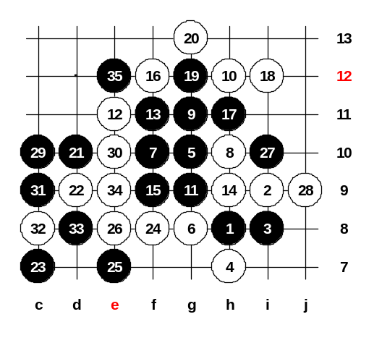
奕學 : Mar 4 15:59
這是今晚助教(fivestar)提供的上週習題之題解.
白12, 16, 18若反擋, 黑皆簡單勝.
22, 24都是最強防.
23, 25 妙佈! 27必要!
32, 34衝完後 f13 四三,外加未擋的活三. 黑勝定 !!

finite555 : Mar 16 20:49
29 關鍵的衝四 不然黑白棋有衝雙三喔
29 is still key move or white has VCF.
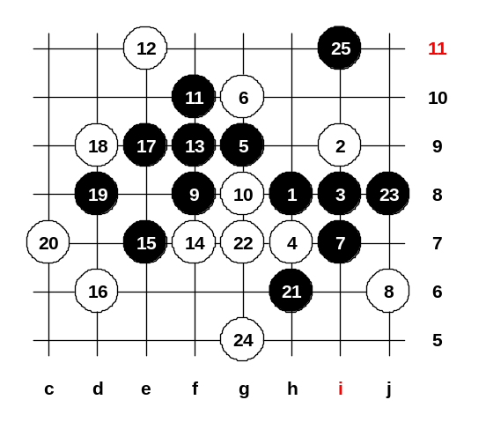
奕學 : Mar 4 16:14
白6有三個落點:g10,g8,f8.
舊定石下7-f10, 但很難勝.
7-i7 是俄國棋仕發現的好棋.
11, 13, 15, 17手順正常.
19必要, 20沒影嚮.
21妙著, 23勝定 !

奕學 : Mar 4 16:17
23後, 上有 VCF, 下有四三 !(那就是19的作用啦.)

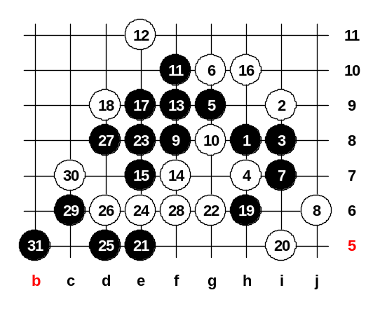
Mar 2 23:18
The 21-e5 is the key move! ^^
After 27-d8 black has VCF threat, so white must play a four to f6 first.
Now, 31-b5 is 4x3. But remember, this was i6 opening. If it is d6 opening then there is one line less on that side. However, even if there is one line less on the left side, black still wins b5, f5, g5 (4x3).
Homework: find the win if 20-g7. Good luck and see you! ^_^

萬盤棋 : Mar 6 23:25
21-e6, 22-e8, 23-g6, 24-f6, 25-f4, 26-j8 (black has VCF) 27-e3, 29-d6, 31-e5 or 26-g5, 27-c7, 29-d6 (4x3).

Mar 16 23:17
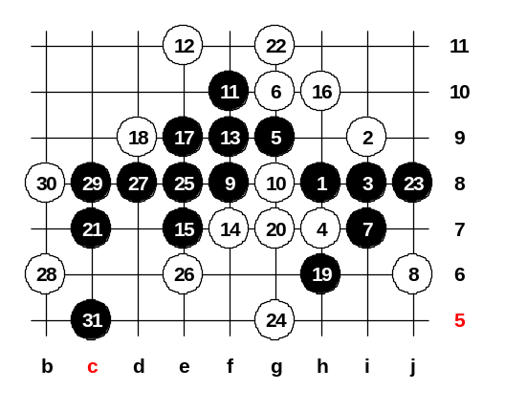
How about today? Is there still questions about i6 opening or we will take new opening today? If any questions, please say it and we will study it together.
Ok, lets set up homework.
I want to know, how many people solved the homework. Please tell me. Did anyone of you find the answer? The win is very easy. ^_^ No, not e6... Not g6 either.
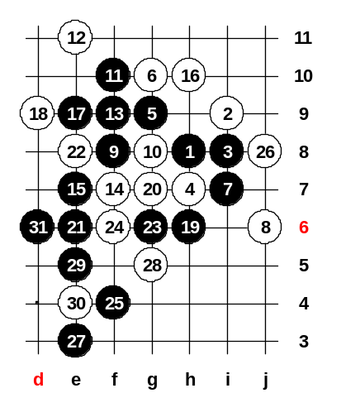
The win is easy, c7 ^^ Now, black wants to play f4 and d6, so white must play g10. Here comes the black win. Do you want to try if e6 is win too?

Mar 16 23:20
Good! ^_^ e6 is win too.

Mar 16 23:21
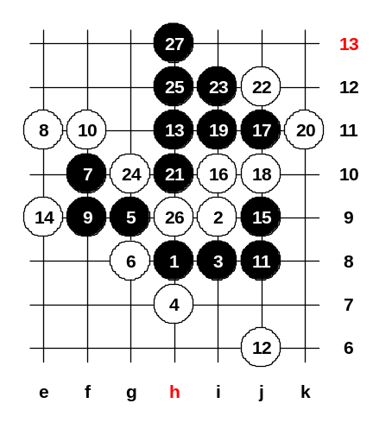
Lets see another 6th move now.
Ok, g8, as you wish ^^
The 7-f10 is the good move. 8-i7 is really bad because of 9-f9. The 10-f11 is the strongest for white. The Latvia player Aldis Reims found a black win move here, it is 11-j8!! The idea is to use all the connections between the right and the left side. In many cases, the black diagonal line h9_i8_j7 is the key line for black win. We can try to play one test way here, just as you wish. You can tell the white moves, I try the black steps. The i10 seems to have some problems, j9 looks black win. No matter the white stop now, black next moves are j11, i11, h10.
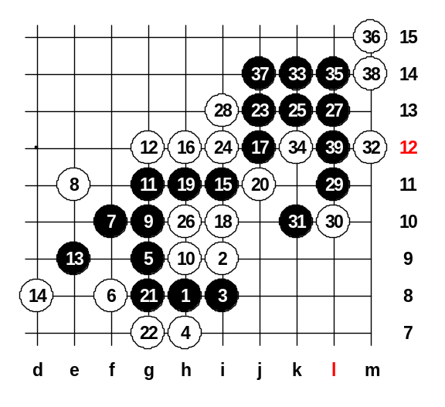

Mar 16 23:22
Lets look another 6th move now, how about f8? Same 7th move here, a three. I agree 10-h9 is the strongest. If 14-h12 then 15-d9 is easy black win. Look at the connection now, h12, k9, i7, g8, j8. Yes, therefore, white must play 16-h12. Yes, 17-j12 is a Japanese move. The 33-k11 was even easier win.

Mar 9 23:09
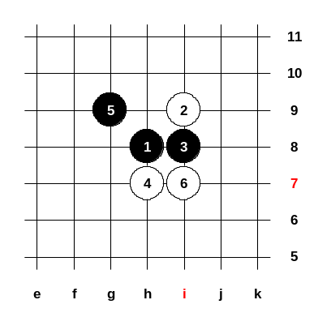
This is the last 6th move we look. However, your homework is to find how black should play after such 6th move. We need make 10 stones on board, otherwise we cannot save the game in 5lin. I have a question to you. What opening shall we study next week? i6 is over. d11, d8, d3, i12, i6 are over. In future, we can repeat some openings of course, because theory changes every year, but now is too early to repeat d11. The i11 is a good opening, very important. Even in last World Championship, Sinyov used i11 in A-final. OK, agreed. I will prepare i11 for next week. Thank you all for joining the class today! See you next Thursday!

Mar 16 22:03
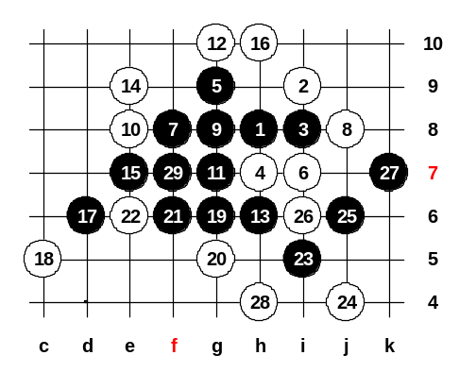
Hello, lets go! ^___^ We will check the homework first. So, please tell me your answers. fivestar says 7-f8. Anybody else has more ideas? Somebody says j7, good. ^^ Any other ideas? I believe 7-f8 is very strong, although 7-j7 is fine move too. The 7-g10 is not good because of 8-j7. If 7-j7 then it becomes i11 opening with the sequence h8, i7, g9, h7, j7, i9, i8. That variant in i11 opening is black win too, but it is very difficult. I believe 7-f8 is easy way, just as fivestar suggested. Lets try 8-j8 first. Must 12-g10. If 16-d6 then 17-g5, 19-f6, see? Any 28th, doesn’t matter.

Mar 16 23:15
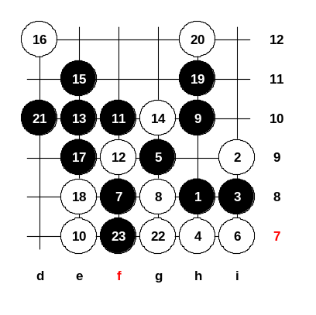
This time we stop the three from the middle. And now, how to play? Ok, we play 9-h10. Fivestar says 11-f10, no matter which 10th move. Hmm, what white can do now? Try 12-f9. Please somebody say black steps. The win is simple, just don't need to play too many fours. Because, later black will have choice of f11 and g11 points. So, the win move is simply 21-d10. Now, there is no stop anymore. We can close the diagram. Any questions about this?

